

**Arjun Bakshi - BT18GEC134**

**Code:**

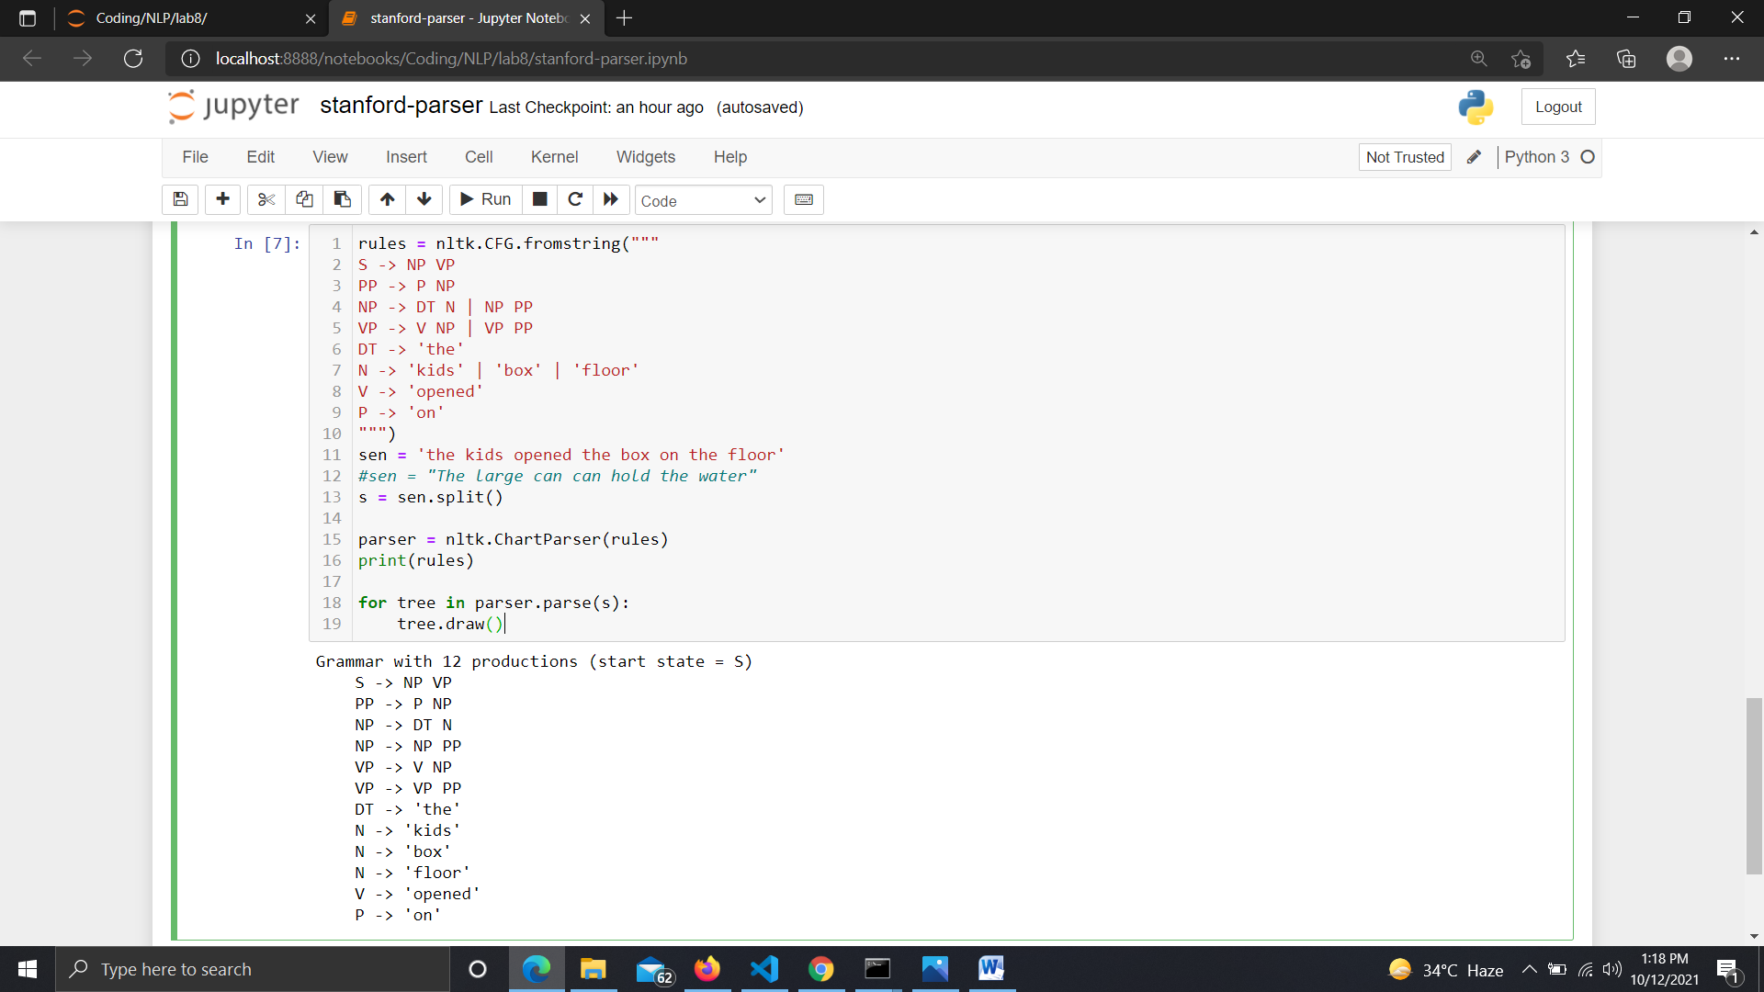

**Sample sentence :** changed from ‘quick brown fox jumped over the lazy dog ’ to ‘the kids opened the box on the ground’

**Output Trees as images**: On copy also got same

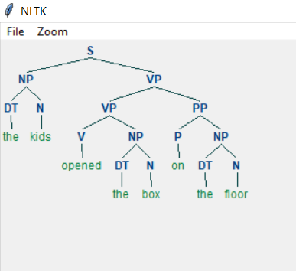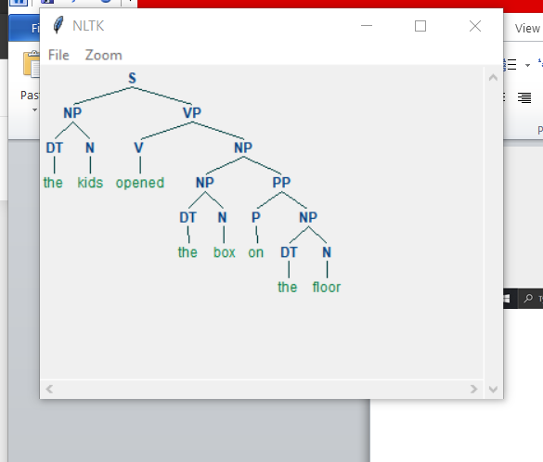

**Analysis:** For given grammar and a sentence there can be more than one way of deriving that sentence from that grammar. Hence we get more than one trees as the parse trees. Both trees are correct.